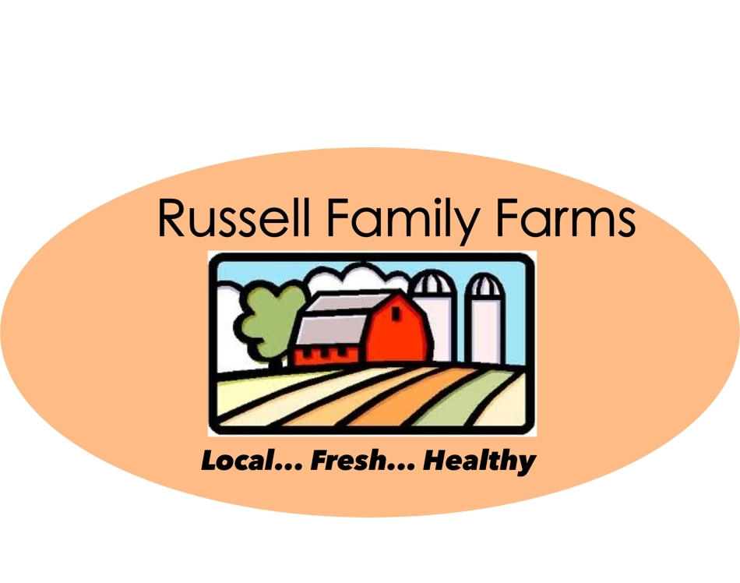

Russell Family Farms
It's What's For Dinner!
(828) 430-0130 www.russellfamilyfarms.com Morganton, NC
________Heritage Pork Price List_______
Baby Back Ribs - $10.00/lb
Bone-In Pork Chops - $10.00/lb
Boneless Pork Chops - $12.50/lb
Bacon (Uncured) - $8.00/lb
Boston Butt - $8.00/lb
Country Backbones - $3.00/lb
Ham (Uncured) - $8.00/lb
Jowls - $5.00/lb
Leaf Lard (Un-rendered) - $4.50/lb
Liver - $3.50/lb
Ground pork - $7.25/lb
Sausage-Breakfast - $7.25/lb (Mild or Hot)
Italian Sausage Links - $8.25/lb
Bratwurst Links - $8.25/lb
Andouille Links - $8.25/lb
Chorizo Links - $8.25/lb
Shanks - $3.75/lb
Spare Ribs - $9.00/lb
Tenderloin - $16.00/lb

